Biography of Arda Gerkens

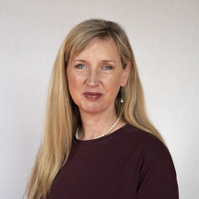

Full name: Ardina (Arda) Meinoutje Vera GERKENS
Place of birth: Naarden, Netherlands
Date of birth: 5 June 1965
Residence: Haarlem, Netherlands
Member of Senate: since 14 May 2013
Gender: Female
Parliamentary Party: Socialist Party

Arda Gerkens is Vice-President of the Senate since July 2019 and member of the following committees and interparliamentary delegations:

- Economic Affairs and Climate / Agriculture, Nature and Food Quality
- Kingdom Relations
- Public Health, Welfare and Sport
- Dutch Group at the Interparliamentary Union
- Dutch Delegation of the Benelux Interparliamentary Assembly
- Interparliamentary Committee of the Dutch Language Union

Education:

- Amsterdam University of Applied Sciences, Post-HBO Organisation, Policy & Management, 1995
- New Teacher Training Course (Vrije Leergangen), VU Amsterdam, in Dutch and Religious Education, 1990

Career:

- Managing Director Expertise Bureau Online Child Abuse (Dutch hotline), since 2015
- President of Dutch Association of Producers and Importers of image and sound carriers (NVPI), Dutch trade association for the entertainment industry, since 2020
- Chair of the IJsselmeer Transition Foundation, since 2015
- Member of the House of Representatives (Tweede Kamer) 2002-2010

